**RECORDING AND POSTING A VIDEO WITH ZOOM & KALTURA**

1. 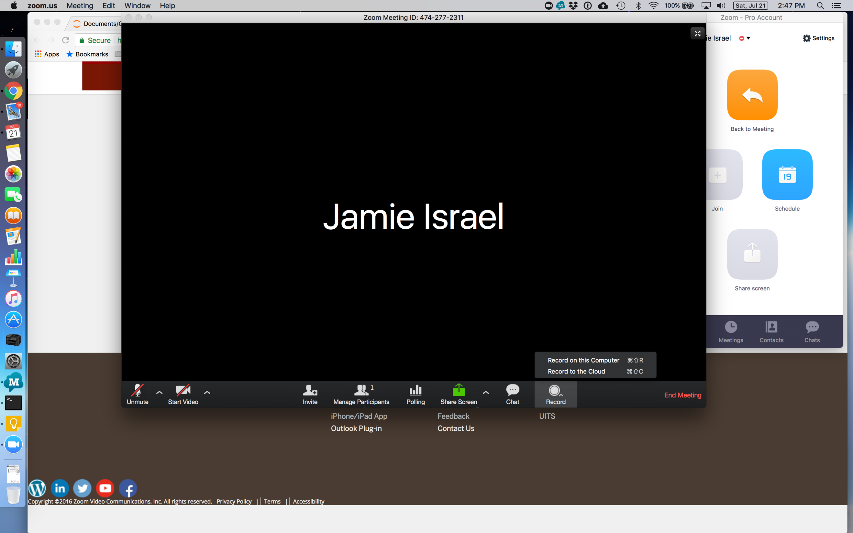While your zoom meeting is running, select “Record to the Cloud” from the record options.
2. 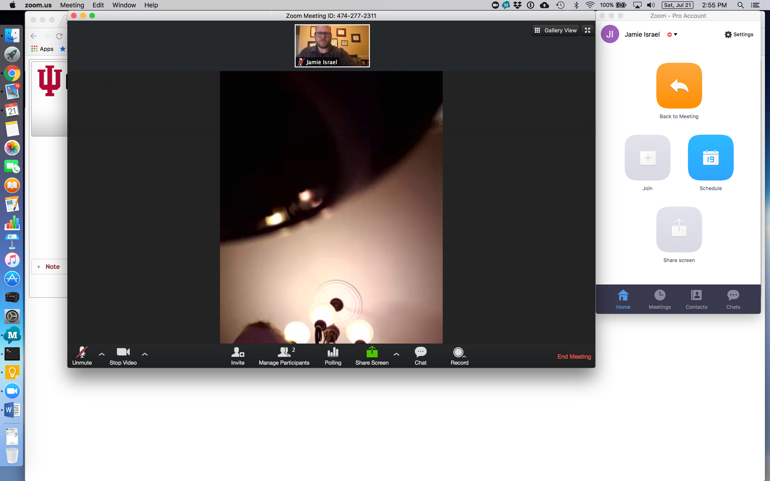Make sure you are in “Speaker View” if you want the person who is speaking to automatically show up in the corner of the video. You will know you are in speaker view if the words “Gallery View” appear on the screen (clicking this will switch you to gallery view).
3. 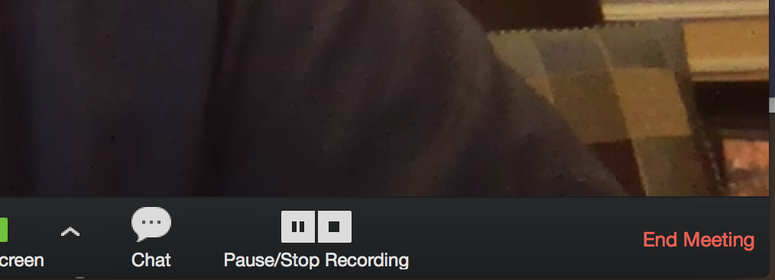When you are done, click the stop (square) icon to stop your recording. This automatically begins the process of encoding your video and adding it to your IU Kaltura account.
4. Once your video is done processing and available to access, you will receive an email titled, “Your Zoom@IU Cloud Recording . . . has finished processing.”
5. You can access the video by logging into Kaltura (kaltura.iu.edu), clicking on your name (top right of the screen) and choosing “My Media”.

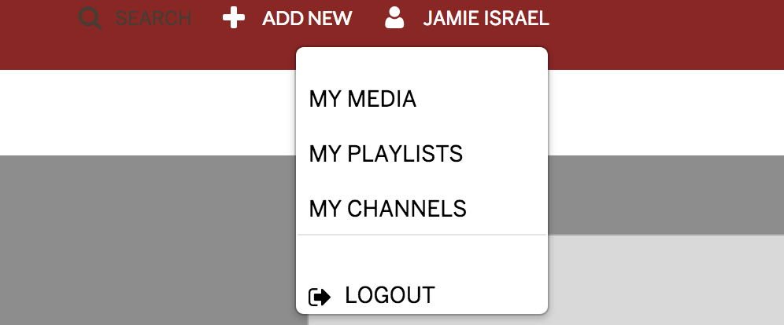

1. Click on the pencil icon next to your video to edit the name and other settings or to access the video editor where you can do additional processing (e.g., crop the beginning and end).
2. When posting your final project results for the class, you can embed your video into a discussion board message by clicking the Kaltura icon. in the message editor and selecting a size for whichever video you wish to embed.

